Mathematical experiences for very young children should build largely upon their play and the natural relationships between learning and life in their daily activities, interests, and questions.

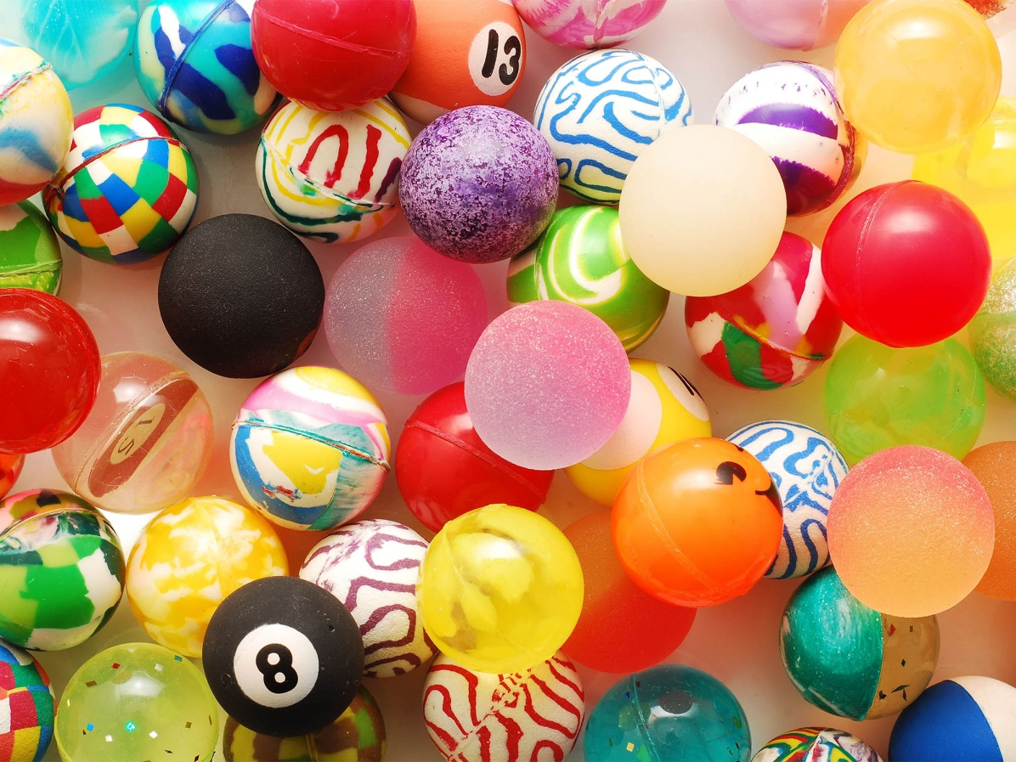

Grades

https://www.scholastic.com/etc/designs/default/0.gif

Four-year-old Nita is playing with four dolls that came from a set of six. Passing by, her teacher inquires, "Where are the others?" Her teacher overhears Nita say, "Ummm...[pointing to each doll] I'm calling you 'one.' You're 'two' and 'three' and 'four.' Where are your sisters, 'five' and 'six'?" She plays with the dolls for another minute. "Oh! You are 'six'? And you are 'five'? Well, let's go find sisters 'three' and 'four.' I gotta find them, too."

Nita incorporated counting into her play to keep track of her dolls. We know play is important to young children's development, so it isn't surprising that children's play is the source of their first "pre-mathematical" experiences.

**Exploring the Math in Play**

Children become intensely engaged in play. Pursuing their own purposes, they tend to tackle problems that are challenging enough to be engrossing yet not totally beyond their capacities. Sticking with a problem — puzzling over it and approaching it in various ways — can lead to powerful learning, in addition, when several children grapple with the same problem, they often come up with different approaches, discuss various strategies, and learn from one another. These aspects of play can promote thinking and learning in mathematics as well as in other areas.

Young children explore patterns and shapes, compare sizes, and count things. But how often do they do that? And what does it mean for children's development? When children were studied during free play, six categories of mathematics content emerged.

**1. Classifying.** One girl, Anna, took out all the plastic bugs from the container and sorted them by type of bug and then by color.

**2. Exploring magnitude** (describing and comparing the size of objects). When Brianna brought a newspaper to the art table to cover it, Amy remarked, "This isn't big enough to cover the table."

**3. Enumerating** (saying number words, counting, instantly recognizing a number of objects, or reading or writing numbers). Three girls drew pictures of their families and discussed how many brothers and sisters they had and how old their siblings were.

**4. Investigating dynamics** (putting things together, taking them apart, or exploring motions such as flipping). Several girls flattened a ball of clay into a disk, cut it, and made "pizza."

**5. Studying pattern and shape** (identifying or creating patterns or shapes, or exploring geometric properties). Jennie made a bead necklace, creating a yellow-red color pattern.

**6. Exploring spatial relations** (describing or drawing a location or direction). When Teresa put a dollhouse couch beside a window, Katie moved it to the center of the living room, saying, "The couch should be in front of the TV."

The range of mathematics explored during free play is impressive. We can see that free play offers a rich foundation on which to build interesting mathematics. These everyday experiences form the foundation for later mathematics. Later, children elaborate on these ideas. We call this process "mathematization." And we recognize that children need both these foundational experiences, as well as specific math activities.

Play does not guarantee mathematical development, but it offers rich possibilities. Significant benefits are more likely when teachers follow up by engaging children in reflecting on and representing the mathematical ideas that have emerged in their play. Teachers enhance children's mathematics learning when they ask questions that provoke clarifications, extensions, and development of new understandings.

**Math 'N Blocks: Towers of Learning**

The benefits of block building are deep and broad. Children increase their math, science, and general reasoning abilities when building with blocks. Consider how block building develops.

Infants show little interest in stacking. Stacking begins at 1 year, when infants show their understanding of the spatial relationship "on." The "next-to" relationship develops at about 1 ½ years. At 2 years, children place each successive block on or next to the one previously placed. They appear to recognize that blocks do not fall when placed this way. Children begin to reflect and anticipate. At 3 to 4 years of age, children regularly build vertical and horizontal components within a building. When asked to build a tall tower, they use long blocks vertically, because, in addition to aiming to make a stable tower, their goal is to make a stable tall tower, first using only one block in this fashion, then several. At 4 years, they can use multiple spatial relations, extending their buildings in multiple directions and with multiple points of contact among the blocks, showing flexibility in how they build and integrate parts of the structure.

Preschoolers employ, at least at the intuitive level, more sophisticated geometric concepts than most children experience throughout elementary school through block play. For example, one preschooler, Jose, puts a double unit block on the rug, two unit blocks on the double unit block, and a triangle unit on the middle, building a symmetrical structure.

Consider a preschooler who is making the bottom floor of a block building. He lays two long blocks down, going in the same direction. Then he tries to bridge across the two ends with a short block. It doesn't reach, so he moves an end of one of the long blocks so it will reach. However, before he tries the short block again, he carefully adjusts the other end of the long block. He tries the short block. It reaches across. He quickly places many short blocks, creating the floor of his building.

We learn a lot from this episode and others like it. Just as this little boy did, many children intuitively use the concepts of parallel and perpendicular. The boy even seems to understand-in his actions-that parallel lines are always the same distance apart!

We have observed other children adjusting two cylinders so that the distance between them just equals the length of a long block. They estimate how many more blocks they need to finish a surface. They estimate that eight blocks were needed if each of four sizes of a square are covered with two blocks. We know many math teachers who would be thrilled if their students showed similar insight into geometry, measurement, and number!

**Rhythm and Patterns**

Preschoolers also engage in rhythmic and musical patterns. They can add more complicated, deliberate patterns, such as "clap, clap, slap; clap, clap slap" to their repertoires. They can talk about these patterns, representing the pattern with words. Kindergartners enjoy making up new motions to fit the same pattern, so clap, clap slap is transformed into jump, jump, fall down; jump, jump, fall down, and soon, is symbolized as an AABAAB pattern. Kindergartners can also describe such patterns with numbers ("two of something, then one of something else"). These are actually the first clear links among patterns, number, and algebra.

Children who have had these rhythmical experiences will intentionally recreate and discuss patterns in their own artwork. One 4-year-old loved knowing the rainbow colors (ROY G BFV, for red, orange, yellow, green, blue, indigo, violet) and painted rainbows, flowers, and designs that repeated this sequence several times.

**Math Flows Through Water Play**

Measurement frequently underlies play in the water or sand table. A researcher tells of visiting two classrooms in the same day, observing water play in both. Children were pouring in each room, but in one they were also excitedly filling different containers with the same cup, counting how many cupfuls they could "fit" in each container. The only difference between the two classes was that in the latter the teacher had passed by and casually asked, "I wonder which of these holds the most cupfuls of water?"

**Rolling Out Math Concepts!**

Materials such as sand and play dough offer many rich opportunities for mathematical thinking and reasoning. Teachers can provide suggestive materials (cookie cutters), engage in parallel play with children, and raise comments or questions regarding shapes and numbers of things. For example, they might make multiple copies of the same shape in play dough with the cookie cutters, or transform sand or play dough into different objects. One teacher told two boys she was going to "hide" the ball of play dough, covering it with a flat piece and pressing down. The boys said the ball was still there, but when she lifted the piece, the ball was "gone." This delighted them and they copied her actions and discussed that the ball was "in" the flat piece.

**Math 'n' Manipulatives**

Children's play with manipulatives, including combining "flat" blocks to make pictures and designs and also to complete puzzles, reveals a developmental progression as does block building. Children at first are unable to combine shapes. They gradually learn to see both individual pieces and a "whole," and learn that parts can make a whole and still be parts. By about 4 years old, most can solve puzzles by trial and error and make pictures with shapes placed next to one another. With experience, they gradually learn to combine shapes to make larger shapes. They become increasingly intentional, building mental images of the shapes and their attributes, such as side length and angles.

**Building Concepts With Computers**

Picture making with shapes can be done with building blocks as well as computer shapes. Computer versions have the advantage of offering immediate feedback. For example, shapes can be transparent so children can see the puzzle beneath them. In addition, children often talk more and explain more of what they are doing on computers than when using other materials. At higher levels, computers allow children to break apart and put together shapes in ways not possible with physical blocks.

Computers can help facilitate play in other ways, too. The addition of a computer center does not disrupt ongoing play but eases positive social interaction and cooperation. Research shows that computer activity is more effective in stimulating vocalization than play with toys, and also stimulates higher levels of social play. Also, cooperative play at the computer is similar to the amount of cooperative play in the block center. Cooperation in a computer center can provide a context for initiating and sustaining interaction that can be transferred to play in other areas as well, particularly for boys.

**Dramatic Mathematics**

Dramatic play can be naturally mathematical with the right setting. In one study, teachers and children put together a shop in the dramatic-play area, where the shopkeeper fills orders and asks the customer for money ($1 for each dinosaur toy).

In one classroom, Gabi was the shopkeeper. Tamika handed her a five card (5 dots and the numeral "5") as her order. Gabi counted out five toy dinosaurs.

**Teacher (just entering the area):** How many did you buy?

**Tamika:** Five.

**Teacher:** How do you know?

**Tamika:** Because Gabi counted. (Tamika was still working on her counting skills, and trusted Gabi's counting more than her own knowledge of five. The play allowed her to develop her knowledge.)

**Janelle:** I'm getting a big number. (She handed Gabi a 2 and a 5 card.)

**Gabi:** I don't have that many.

**Teacher:** You could give Janelle 2 of one kind and 5 of another.

As Gabi counted out the two separate piles and put them in a basket, Janelle counted out dollars. She miscounted and gave her $6.

**Gabi:** You need $7.

This dramatic-play setting, with the teacher's help, "worked" for children at different levels of mathematical thinking.

**Play Before Problem Solving**

We have seen how different types of play enhance children's mathematical thinking. Studies also show that if children play with objects before they are asked to solve problems with them, they are more successful and more creative. For example, one study with three groups of 3- to 5-year-olds asked them to retrieve an object with short sticks and connectors. One group was allowed to play with the sticks and connecting devices, one group was taught how the sticks could be connected, and one group was asked to tackle the task without prior play or learning. The first two groups performed similarly and achieved better results than the third group. Often, the group that simply played with the sticks and connectors first solved the problem more quickly than the group that was taught how to use them.

**Mathematical Play**

This brings us to the final fascinating and usually overlooked type of play: mathematical play. Here, we do not mean play that involves mathematics — we've been talking about that throughout this article. We mean playing with mathematics itself.

Think again about Nita and her dolls. When she named them to identify the "sisters" she wasn't playing with, she was using math in her play. But when she decided that she would rename the dolls she had with her from "five" and "six" to "three" and "four," she was playing with the notion that the assignment of numbers to a collection of objects is arbitrary. She also counted not just the dolls but the counting words themselves. She counted the words "three, four" to see there were two sisters missing. She was playing with the idea that counting words themselves could be counted.

The dynamic aspects of computers often engage children in mathematical play more so than do physical manipulatives or paper materials. For example, two preschoolers were playing with activities called "Party Time" from the Building Blocks project in which they could put out any number of items, with the computer counting and labeling for them. "I have an idea!" said one girl, clearing off all the items and dragging placemats to every chair. "You have to put out cups for everybody. But first you have to tell me how many cups that'll be." Before her friend could start counting, she interrupted: "And everyone needs one cup for milk and one for juice!" The girls worked hard cooperatively at first, trying to find cups in the dramatic-play center, but finally counting two times on each placemat on the screen. Their answer — initially 19 — wasn't exact, but they were not upset to be corrected when they actually placed the cups and found they needed 20. These children played with the mathematics in the situation, with solutions, as they played cooperatively with one another.

Mathematics can be intrinsically interesting to children if they are building ideas while engaged in mathematical play.

**Promoting Math in Everyday Play**

Teachers support math in play by providing a fertile environment and intervening appropriately. Here are some things you can do:

**Observe children's play.** When you haven't seen many new block constructions, share books illustrating different block arrangements, or post pictures in the block center. When you see children comparing sizes, offer different objects that children can use to measure their structures, from cubes to string to rulers.

**Intervene sensitively.** A useful strategy is to ask if the social interaction and mathematical thinking are developing or stalled. If they are developing, simply observe and leave the children alone. Discuss the experience later with the whole class.

**Discuss and clarify ideas.** Children might each argue that their block building is bigger. You may see that one child is talking about height and another is talking about width. You can comment on how you see the buildings as big in different ways, as in "You have a very tall building, and Chris' seems to be very wide."

**Schedule long blocks of time for play.** Provide enriched environments and materials, including structured materials, such as blocks and Legos, which invite mathematical thinking.

Young children engage in significant mathematical thinking and reasoning in their play — especially if they have sufficient knowledge about the materials they are using — if the task is understandable and motivating and if the context is familiar and comfortable. Math can be seamlessly integrated with children's ongoing play and activities, but it requires a knowledgeable teacher who creates a supportive environment and provides appropriate challenges, suggestions, tasks, and language. In classrooms where teachers are alert to all these possibilities, children's play enriches mathematical explorations.

**Teacher Resources: Websites**

Teachers' most important role, with respect to mathematics, should be finding frequent opportunities to help children reflect on and extend the mathematics that arise in their everyday activities, conversations, and play, as well as structuring environments that support such activities.

1. From [NAEYC](http://www.naeyc.org/), an [article showing how you can develop math games based on children's literature](http://www.journal.naeyc.org/btj/200301/MathGames.pdf#xml=http://naeychq.naeyc.org/texis/search/pdfhi.txt?query=math+games&pr=naeyc&prox=sentence&rorder=750&rprox=500&rdfreq=1000&rwfreq=1000&rlead=1000&sufs=2&order=r&cq=&id=452255ad158). NAEYC also offers [Early Childhood Mathematics: Promoting Good Beginnings](http://www.naeyc.org/about/positions/mathematics.asp), a joint position statement of the [National Association for the Education of Young Children (NAEYC)](http://www.naeyc.org/) and the [National Council for Teachers of Mathematics (NCTM)](http://www.nctm.org/).

2. From [Building Blocks](http://gse.buffalo.edu/org/buildingblocks/) (National Science Foundation), ideas for finding the mathematics in and developing mathematics from children's activities.

3. [National Council of Teachers of Mathematics](http://standards.nctm.org/) (NCTM) offers math [standards](http://standards.nctm.org/), Principles and Standards for School Mathematics, and many activities, web-based software environments, and videos. NCTM's "[Teachers Corner](http://www.nctm.org/)" provides information about professional development opportunities, resources, and more.

4. [Mathematical Perspectives](http://mathperspectives.com/)' Teacher Development Center provides PreK to 6th grade mathematics educators with tools, strategies, and assessments that ensure that all students are successful in the study of mathematics and are able to use mathematics to solve problems and to think and reason mathematically.